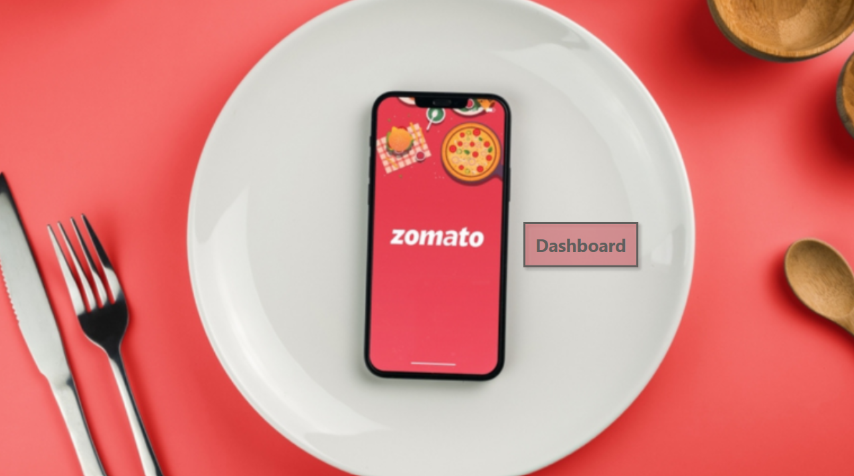

**Page 2:**

**Page 3:**

**Page 4:**

**Data model:**

1. We created card separately for sale of veg, non veg and others. For that, created a relationship using data model. Created relationship between restaurant and orders table. Id from restaurant and r_id from orders table holding same value.
2. Also relationship created between menu and order table. Column r_id is common among them.

**Data transformation:**

1. Menu table data merged with food table data as food table has column ‘Veg or Non veg’ which we need to use with menu table. Menu has column ‘Cuisine’ and we want to know if it is veg or non veg dish so merging will be done, it is like joins. (Home > merge queries) f_id is common column

*Output:*

1. Order table - > sales_qty, sales_amount columns were unpivoted so that in dashboard we can select qty or amount separately. We can use it as a slicer. Select these 2 columns, right click and select unpivot. New column Attribute and value is created.

Attribute column renamed to Type and row – sales_qty changed to Quantity and sales_amt changed to Amount. Column nomenclature changed so that it can be easy to understand.

*Output:*

**DAX :**

For visuals and dashboarding- a separate table created called ‘measures table’. As we have many tables, it will be time consuming if we include measures in those tables. Having a separate table for measures will save us time.

1. *Active users:*

Active Users = DISTINCTCOUNT(orders[user_id])

*Output:*

1. *Current year sale*= (This was created for customers gained and lost)

CurrYrSale =

var Yr = [CurrentYear]

RETURN

CALCULATE([Sale value],orders[Year]=Yr)

1. *Previous year sale*= (This was created for customers gained and lost)

PrevYrSale =

var Yr = [PreviousYear]

RETURN

CALCULATE([Sale value],orders[Year]=Yr)

1. *Dynamic subheading:*

Dynamic subheading = "Zomato providing services in "&DISTINCTCOUNT(orders[city]) & " Cities, connected with "&DISTINCTCOUNT(users[user_id])& " users , and processing "&count(orders[user_id])& "orders."

*Output*: (It was added in overview page below Zomato logo)

1. *Dynamic Top N Title*: (The heading of the chart changes as per user selection)

Dynamic_TopN_title =

var selectedrank = SELECTEDVALUE(RankTable[Type])

var selectedtype = SELECTEDVALUE(orders[Type])

RETURN selectedrank& " city " &selectedtype

*Output*: (When user select top 5 cities by Quantity)

*Output*: (when user selects top 10 cities by Amount)

1. *Gain customer:*

A customer id showing no sale last year, but this year it is showing a sale. So it means we gained this customer.

GainCustomer =

var FilterUsers = FILTER(SUMMARIZE(users,users[user_id]),AND([PrevYrSale]<=0,[CurrYrSale]>0))

RETURN CALCULATE([usercount],FilterUsers)

*Output:*

1. *Lost customer:*

A customer id showing sale last year but no sale against the same customer id this current year, this means customer did not come to us to buy so this will be called lost customer.

LostCustomers =

var FilterUsers = FILTER(SUMMARIZE(users,users[user_id]),AND([CurrYrSale]<=0,[PrevYrSale]>0))

RETURN CALCULATE([usercount],FilterUsers)

*Output:*

1. *Top N Sale*: (User gets to select the top performing cities by number and as per amount and quantity)

For this we created a table first.

*Output:*

And then DAX was created.

*TopN_Sale =*

var RankValue = RANKX(ALL(orders[city]),[Sale value],,DESC)

var SelectedRank = SELECTEDVALUE(RankTable[No])

return

if(SelectedRank=0,[Sale value],

 IF(RankValue<=SelectedRank,[Sale value],blank()))

*Output:*

Above slicer was not in sequence. So to make it in numerical order.

To get the filter values in sequence,

Go to table view- > select the table that contains the filter values

(Rank Table in our case)

Click on ‘Type’ column

Go to Column tools ribbon at the top

click on sort by column and choose sort.

Instead of these dynamic option for filtering, we can do it from visual settings too. But we wanted to give user an option to select so we used DAX.

**Bookmarking use:**

In ‘city performance’ page, we added 3 slicers for city name, restaurant name, and rating. To save the space we created a button, clicking which these slicers should open and clicking again should hide. So using bookmarks it was done.

